Cloud Trail

AWS Cloud Trail is an AWS service and you can use Cloud Trail to view, search, download, archive, analyze, and respond to account activity across your AWS infrastructure.

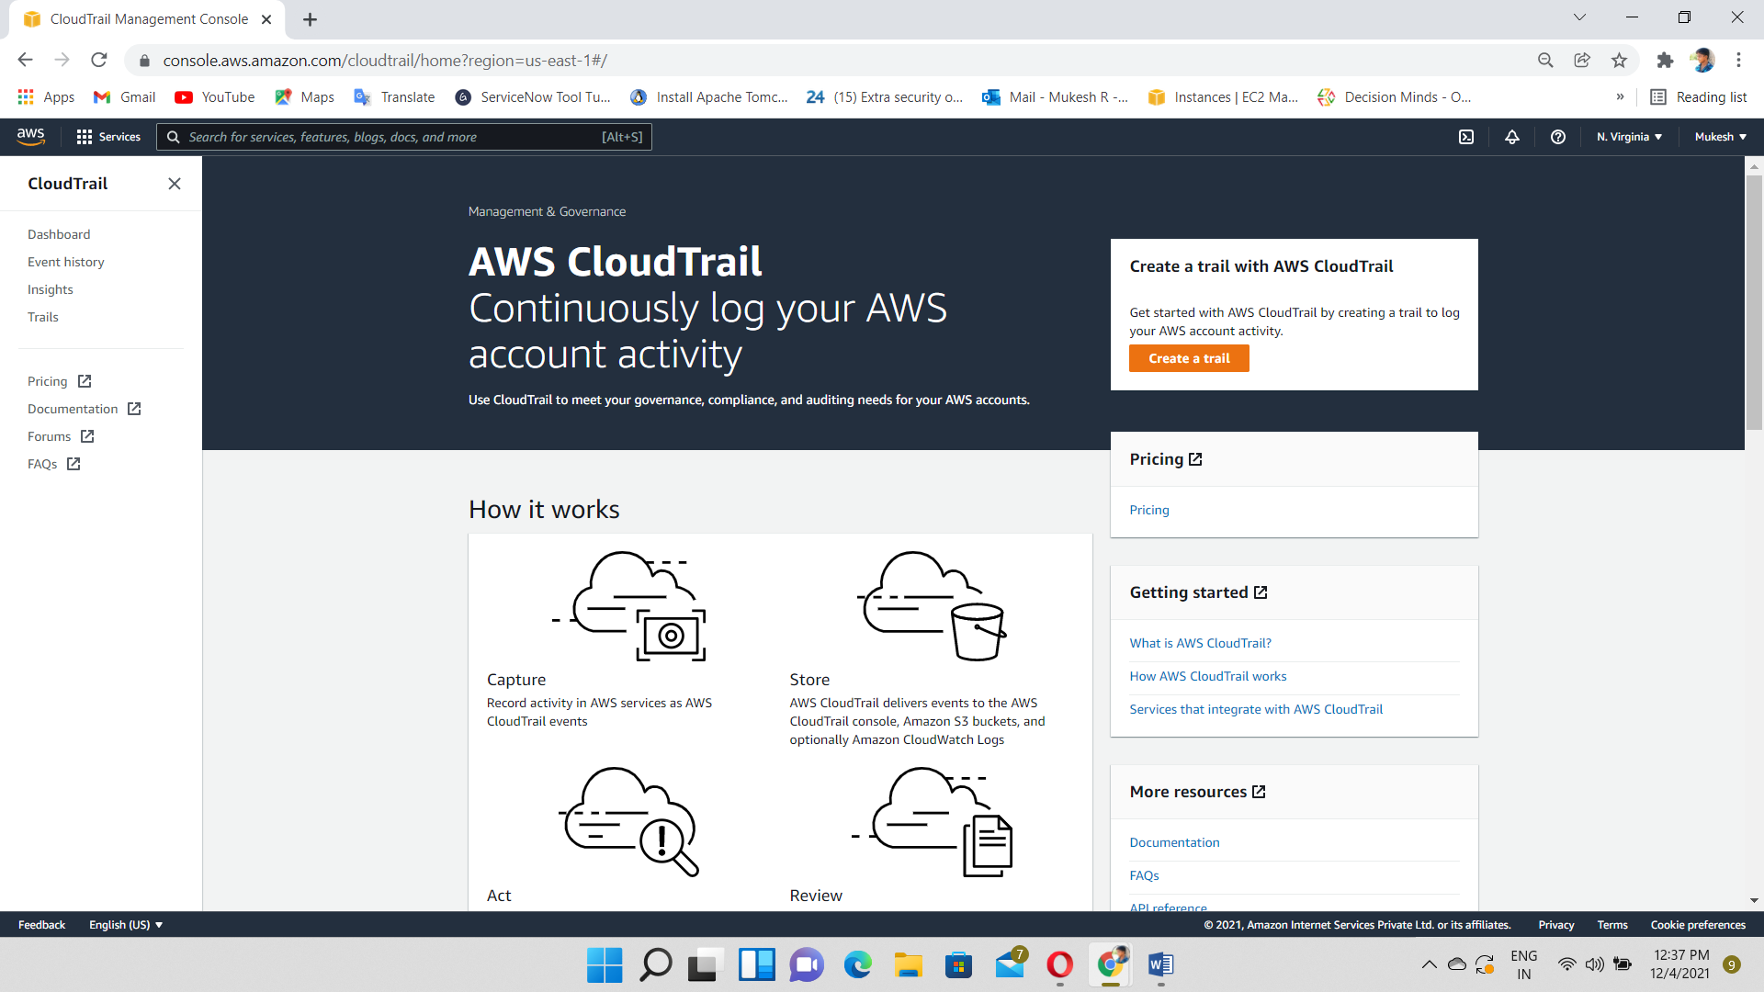

When activity occurs in your AWS account, that activity is recorded in a Cloud Trail event. You can easily view events in the Cloud Trail console by going to Event history.

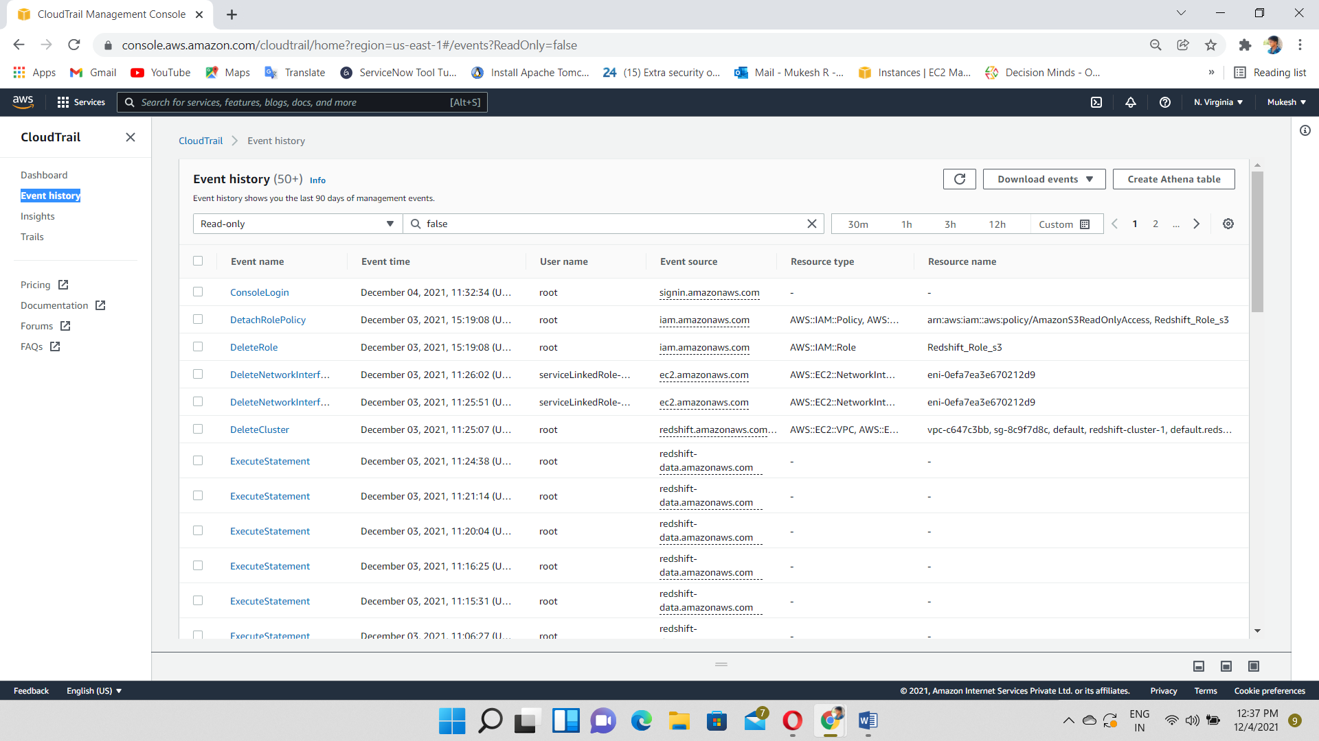

A trail is a configuration that enables delivery of events to an Amazon S3 bucket that you specify.

Event Type🡪 Management events, Data events, Insight events

